Oklahoma Housing Finance Agency REVISED Tax Credit Notice

Please submit any comments, ideas, suggestions, or observations you have for the 2023 Tax Credit Application via our online discussion forum at https://ohfaqapcomments.freeforums.net/ by July 21, 2022. Please follow the attached directions on this document that will give directions for posting and commenting on threads. You will need to login or create an account. It is a public forum. If you are having any difficulty, or have any questions, please contact Corey Bornemann at corey.bornemann@ohfa.org or Edgar Silva at edgar.silva@ohfa.org

Important Dates:

An initial draft of the 2023 QAP is available on OHFA’s website.

Please submit all comments regarding this draft to the online discussion forum by 12:00 PM on July 21, 2022.

A second draft of the 2023 Application will be posted by approximately August 01, 2022. Comments on this second draft will be accepted through August 17, 2022.

The Formal Public Input Session for the 2023 QAP will be held on Wednesday August 17, 2022 from 9:00 AM – 12:00 PM at the Holiday Inn Oklahoma City North, 6200 N. Robinson, Oklahoma City, Oklahoma 73118.

A final draft of the proposed changes to the 2023 Application will be posted on August 24, 2022.

The finalized Application will be taken to the September 21, 2022 Trustees meeting for approval.

The 2023 Application training session will be held in October. The exact date and format will be determined at a later time.

Discussion Forum Instructions: When writing a new post or commenting on someone else’s, please if you would, use a name that clearly identifies who you are and/or on whose behalf you are working.

- This is what the discussion forum will look like. To post or comment, click on the “General Discussion” Board.

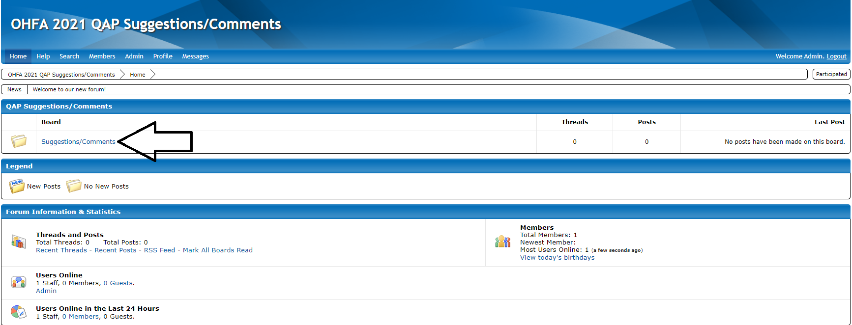

- Once you’ve clicked on the board, you can write a new post by clicking on “Create Thread.”

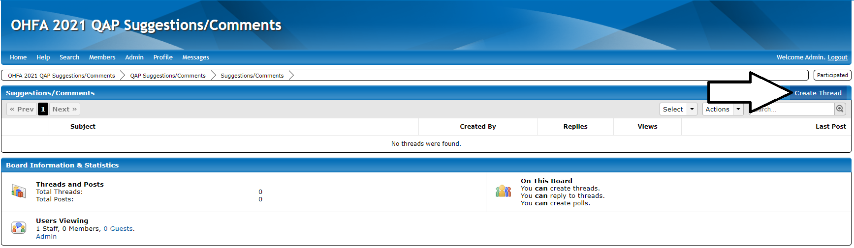

- To reply to someone’s post, simply click on the post.

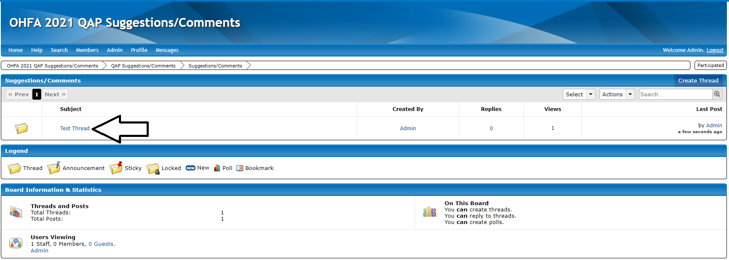

- Then type in your name, your reply, and click “Post Quick Reply.”

